**Pearson Online Textbook Instructions**

1. Go to my homepage and scroll to the bottom. Click on the US History Pearson Textbook link

(A link to Pearson is also found on the District Grades and More page where you login to check your grades)

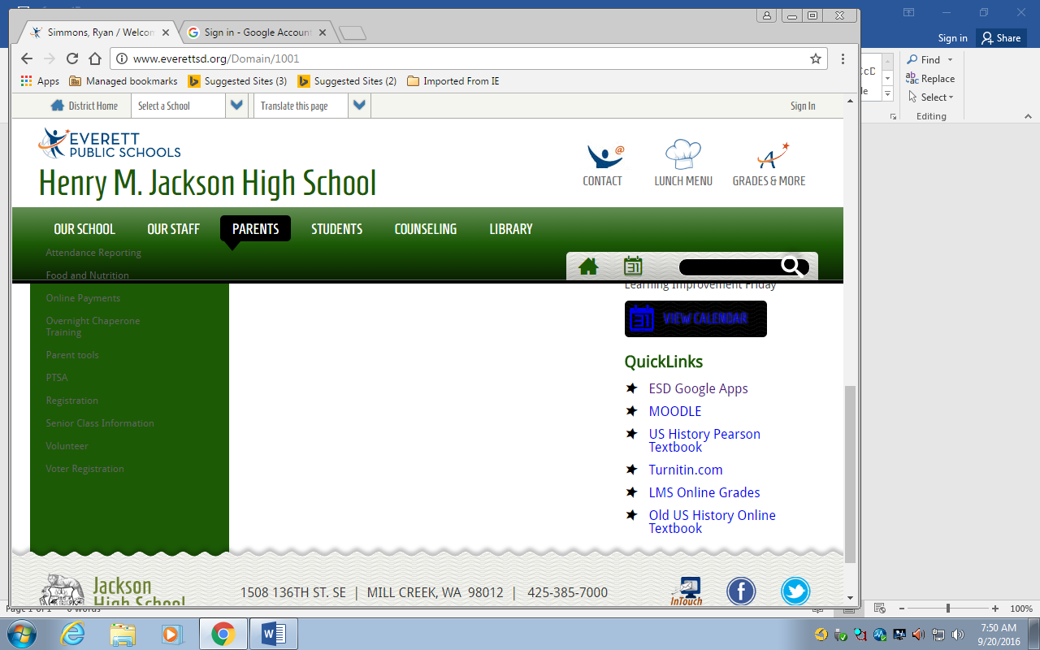

1. This will take you to the Pearson log-in page. Use the same Username/Password Combo you do to log-in to school computers. Click the Pearson EasyBridge Plus button to sign in. DO NOT click the Sign In button

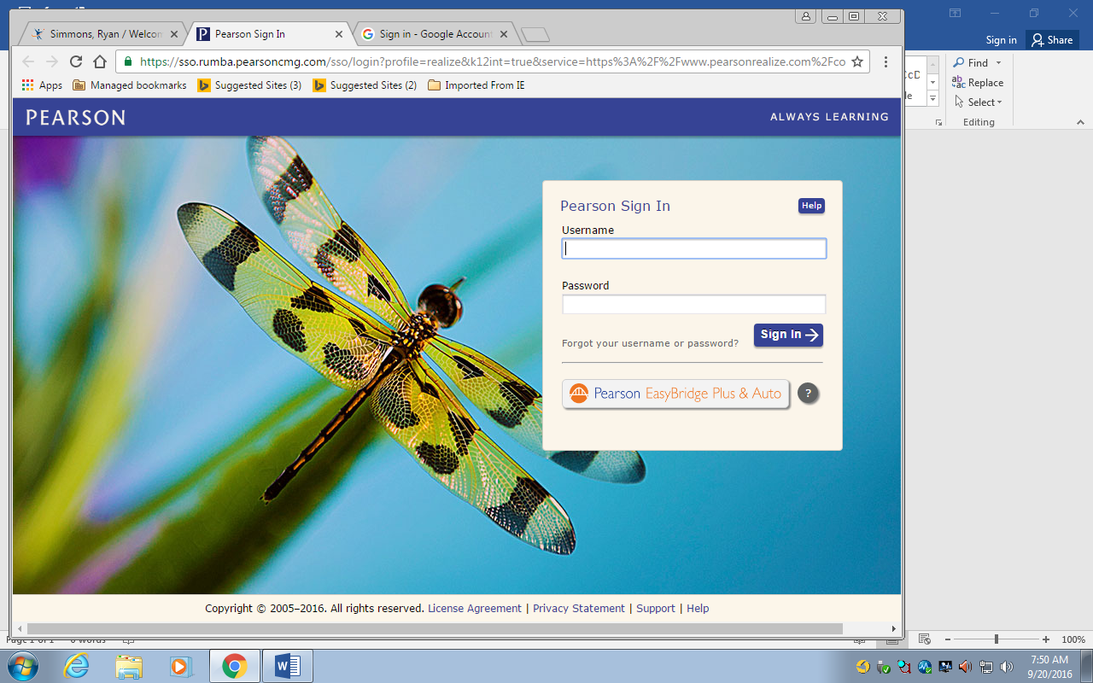

1. Type in Everett then click on EVERETT SCHOOL DISTICT 2 to select the school district. Then click GO

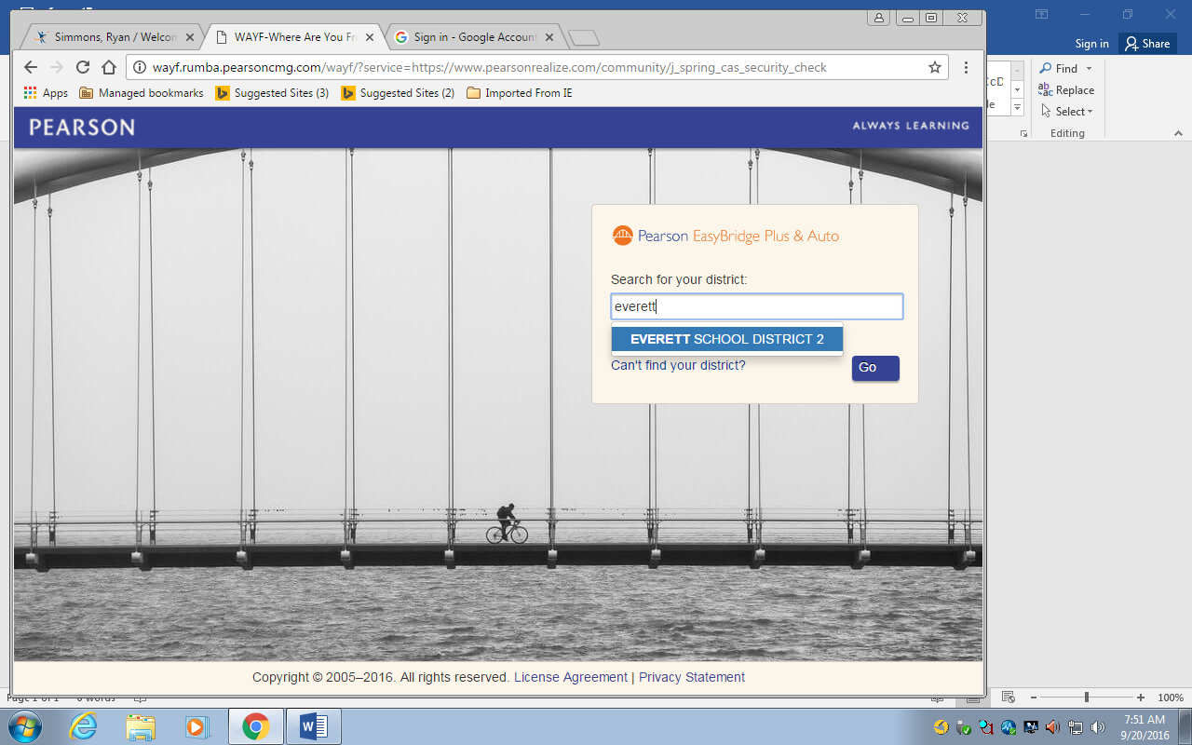

1. Once you’ve logged in you will need to set up your profile. Choose the language, icon, and background. Then hit submit.

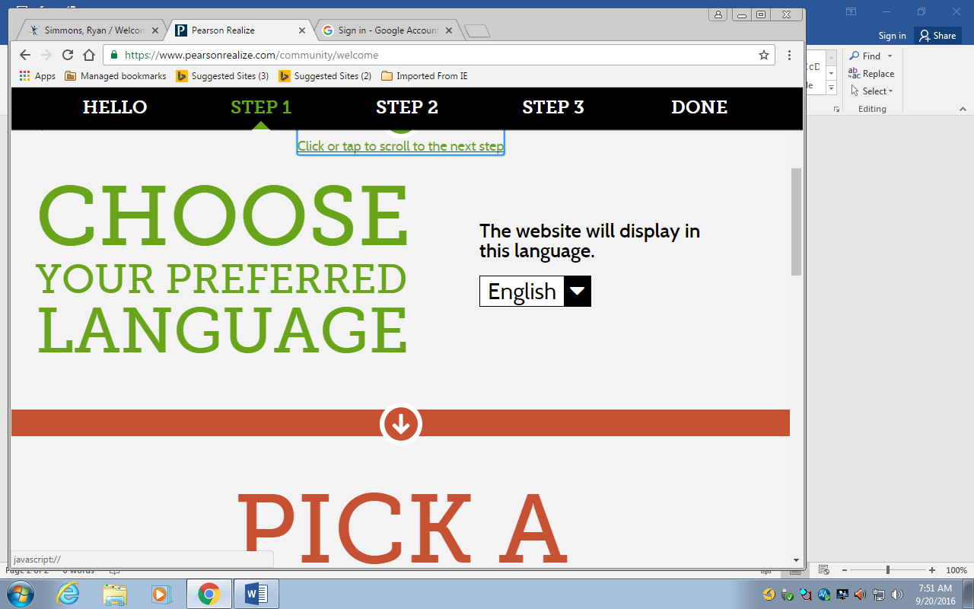

1. This will take you to the Pearson Portal. To access the textbook click on the Green US History box. You can also access anything that I assign in the red boxes.

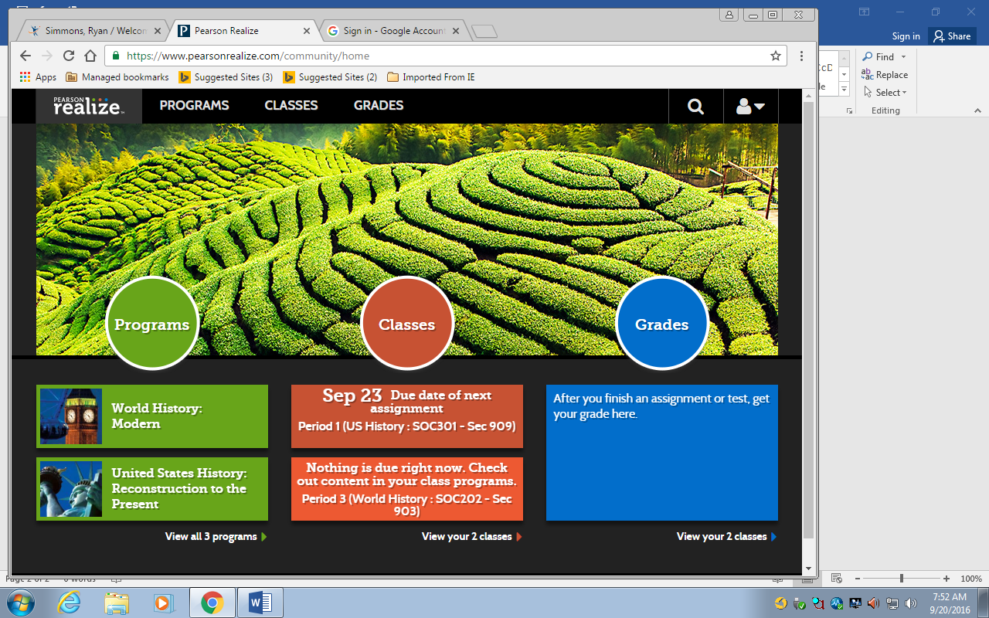

1. To access the textbook click on the Icon associated with the Topic of Study.

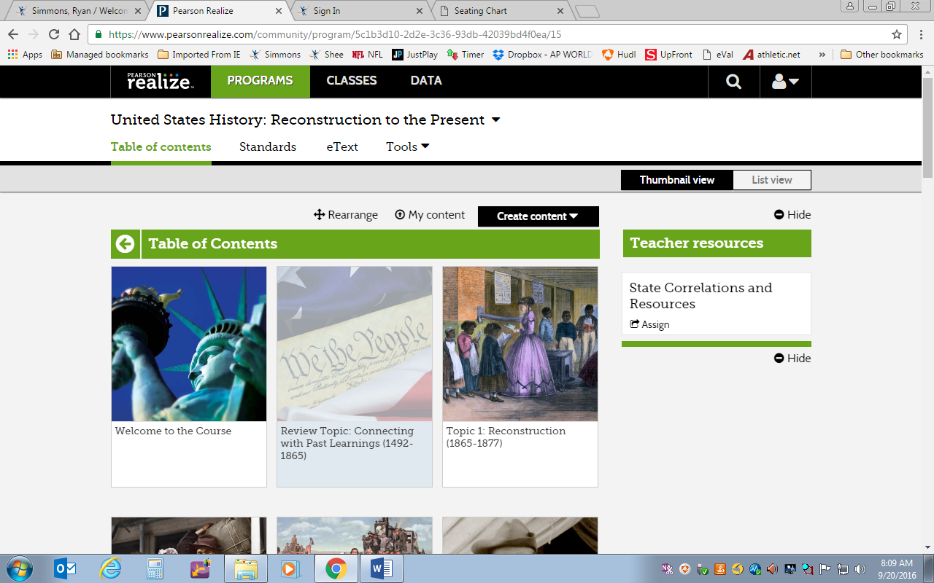

1. Click on the Appropriate Lesson.

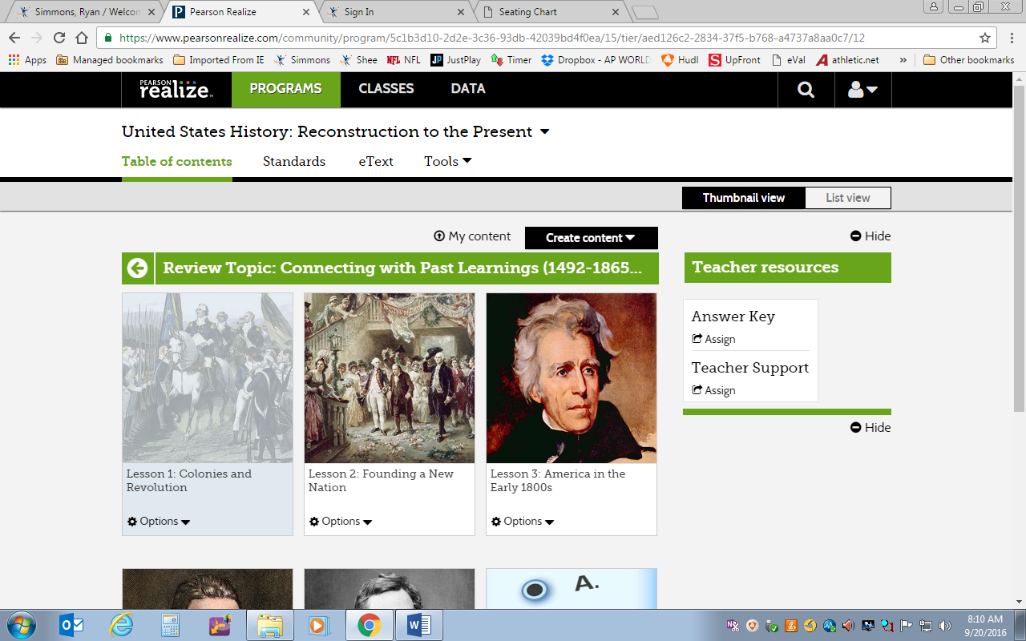

1. The Online text book is broken down into smaller segments based on the subtopics in your physical book. Click on the appropriate reading to access the online version.

